

2017 DEVELOPMENT PROJECTS

FUNDING GUIDELINES
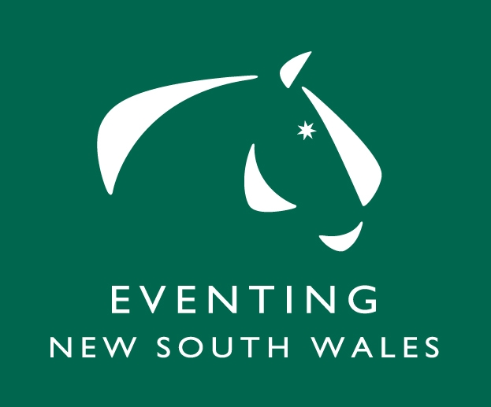

Equestrian NSW and Eventing NSW are committed to continual improvement and development of Eventing so are launching the 2017 Development Projects Program, which were previously called Special Purpose Projects.

How the Development Projects Program Will Work
- Funding for Development Projects is available to Equestrian NSW affiliated Eventing Clubs.
- Funding is available for Projects costing up to $3,000.
- The proposed projects must be delivered in 2017. In March 2017, Expressions of Interest will be invited for projects to be delivered in FY18.
- Submissions are invited which will develop the sport, in particular horse welfare, youth participation, regional development or show creative initiatives to improve the profile of the sport. Capital and equipment projects are permitted, but will be a lower priority. Official’s education, cross country course development and footing are covered under other funding streams.
- Projects where the Club will contribute funds or project costs in kind will be favorably considered. This contribution should be clearly shown on the submitted budget.
- The Equestrian NSW CEO and the Eventing NSW Executive will consider the submissions and make joint recommendations to the Equestrian NSW Board for approval.

How to apply for funding for Development Projects

- Complete and email the 2017 Development Project Funding Application to andrea@ensw.org.au by 20 January 2017.
- Equestrian NSW will advise what projects have been successful in gaining funding by 31 Jan 17.

Project Delivery

- When a project application is approved, 80 per cent of the monies granted will be paid up front to the nominated Project Manager. There may be occasions when the nature of the project justifies payment of the full amount granted.
- Within eight weeks of the completion of the project, the Project Manager must submit a report of the project's execution and a profit and loss account that shows its financial performance.
- For those projects where 80% of the grant is paid up front, ENSW will consider the statements submitted and will then decide whether the remaining 20% should be paid.

BRUCE FARRAR
Chief Executive Officer

2017 DEVELOPMENT PROJECTS

FUNDING APPLICATION

Equestrian NSW affiliated Club Name
Project Name
Name of person submitting this proposal
Contact email address
Contact telephone number
Funding amount requested (max $3,000)
Name of Project Manager
Contact email address
Contact telephone number
Project Start Date |  | Project Finish Date
Detailed Project Description

Project Budget (Income and Expenditure) including funding from other sources

How will this project benefit Eventing?

Please email this Funding Application to andrea@ensw.org.au by 20 December 2016.

